Name ________________________________
(this is an individual Quest. Points earned on this quest will go to individual Adventure Points AND individual XP points)

- Turning this assignment in and receiving and 6 or above on the first try will give you an automatic 15 extra XP points.
- If you are not happy with your score you are allowed to resubmit your assignment as many times as you want to get the highest possible, score that you want- not to exceed 7 Adventure Points)
Parking Cars
This problem gives you the chance to:
• interpret a bar graph
This bar chart shows the number of cars parked in the multi-level parking garage at a shopping center today. Each floor holds up to 50 cars.
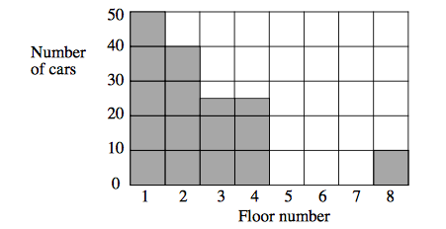

- On which floor are the most cars parked?
How many cars are there on this floor?

- On which two floors are the same number of cars parked?
Floors __________ and __________

- How many more cars are parked on Floor 1 than on Floor 8?
- How many cars, in all, are parked on the parking garage? Show how you figured this out.

- Fifteen more cars come into the parking garage.
Show these cars on the graph, parking them in the lowest floors.

Explain why you parked these cars in this way

Parking Cars Rubric
Elements of performance required by this task are:  Interpret a bar chart  Based on these, credit for specific aspects of performance should be assigned as follows. | Points | Section points | Adventure Points Earned
- Gives correct answers | 1 | 1
- Gives correct answer | 1 | 1
- Gives correct answer | 1 | 1
- Gives correct answer  Shows work | 1  1 | 2
- Draws correct number of cars on the block graph  Gives correct reason for their positioning  Partial credit | 1  1  (1) | 2
Total points |  | 7

